Rabobank Customer Statement Processor

Rabobank receives monthly deliveries of customer statement records. This information is delivered in two formats, CSV and XML. These records need to be validated.

The validation scenarios are provided below,

1. all transaction references should be unique
2. he end balance needs to be validated

After the validation the final output should display both display both the transaction reference and description of each of the failed records.

**Project Details:**

The project is created as a spring boot project and its formed using MVC design pattern.

The functions are separated in different folders like controller, service and model.

The constants are provided in constant folder.

The test cases are available in test folder.

The project requires are third party library as openCSV to process CSV file and JAXB for parsing xml files.

The logging is configured using org.slf4j.

Exception is handled using exception handler

**Package Structure:**

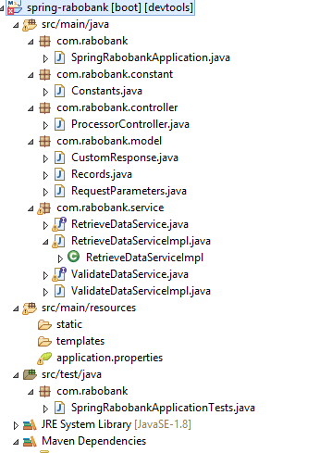

RUN THE APPLICATION:

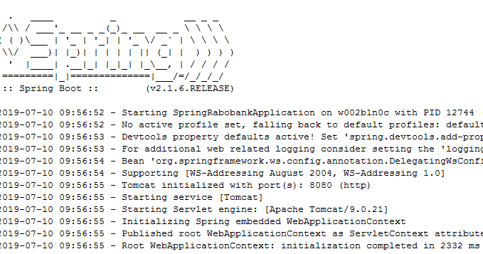

SAMPLE REST REQUEST:

*Request:*

|  |  |  |
| --- | --- | --- |
| **Method** | **URL** | **Header** |
| POST | http://localhost:8080/rabobank/statementprocess |  |
| **Request Body – form-data** | | |
| {  "file": "File that needs to be passed", *\*\*\*\*The file should be csv or xml type\*\*\**  } | | |

*Response:*

|  |
| --- |
| **Success Response Body** |
| {  "responseMessage": "Records with validation error", - *\*\*\*\*status message\*\*\**  "responseCode": 200, *\*\*\*\*status code\*\*\**  "records": [ *\*\*\*\*records passed \*\*\**  {  "transactionRef": 112806,  "accountNumber": "NL90ABNA0585647886",  "startBalance": 32.76,  "mutation": 49.03,  "description": "Clothes from Peter de Vries",  "endBalance": 81.79  },  {  "transactionRef": 112806,  "accountNumber": "NL91RABO0315273637",  "startBalance": 41.63,  "mutation": 12.41,  "description": "Tickets for Erik Dekker",  "endBalance": 54.04  },  {  "transactionRef": 112806,  "accountNumber": "NL69ABNA0433647324",  "startBalance": 45.59,  "mutation": 48.18,  "description": "Subscription for Jan Theu\ufffd",  "endBalance": 93.77  }  ]  } |
| **Failure Response Body** |
| {  "responseMessage": "Please provide a valid csv or xml file",  "responseCode": 415,  } |

**TEST CASES:**

1. Passing invalid file type.

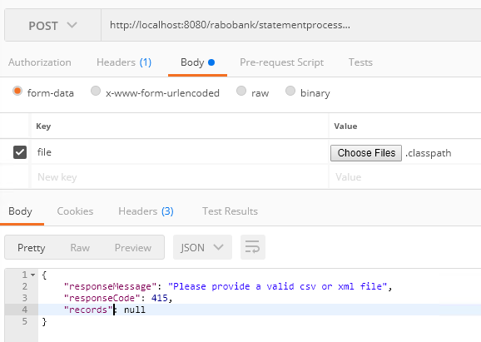

1. Passing empty file as input

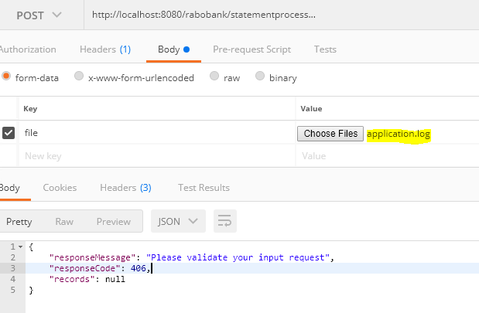

1. Records displayed with validation errors by passing csv file

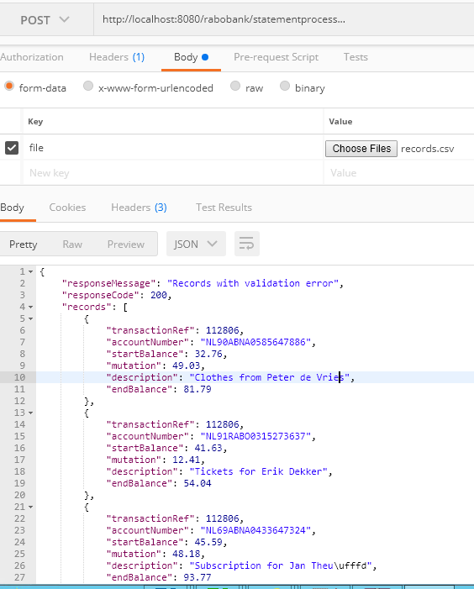

1. Records displayed with validation errors by passing xml file.

